ABC 160D Line++

Given an undirected graph with $n$ vertices and $n$ edges of the following form: $n-1$ edges that connect vertices $i$ and $i+1$, and an extra edge connecting vertices $x$ and $y$ ($x<y$). Find the number of pairs $\left(a, b\right)$ such that $a<b$ and the shortest distance from $a$ to $b$ is $k$, for all $1≤k≤n-1$. ($n≤2000$)

For example, if $n=5, x=2, y=4$, the output should be $5 4 1 0$.

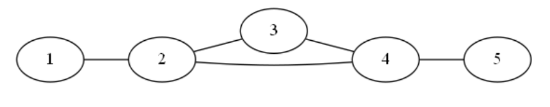shortest distance from $a$ to $b$ is $1$: $\left(1, 2\right), \left(2, 3\right), \left(2, 4\right), \left(3, 4\right), \left(4, 5\right)$

shortest distance from $a$ to $b$ is $2$: $\left(1, 3\right), \left(1, 4\right), \left(2, 5\right), \left(3, 5\right)$

shortest distance from $a$ to $b$ is $3$: $\left(1, 5\right)$

shortest distance from $a$ to $b$ is $4$:

Try to think of a solution before reading on!

Since $n$ is small, an $O\left(n^{2}\right)$ solution should pass. 🡪 We can just iterate for all pairs $\left(a, b\right)$ and compute the shortest distance for each of them!

For each pair $\left(a, b\right)$, you have 2 choices: use $x, y$ edge, or don’t use it.

If you don’t use $x, y$ edge, distance $=b-a$

if you use $x, y$ edge, you need to go from $a$ to $x$, then $x$ to $y$, then $y$ to $b$.

Therefore, distance $=\left|a-x\right|+1+\left|b-y\right|$

